Task 6: The Case of Slip or Trip (0.6 page) due 09/14 at 11am
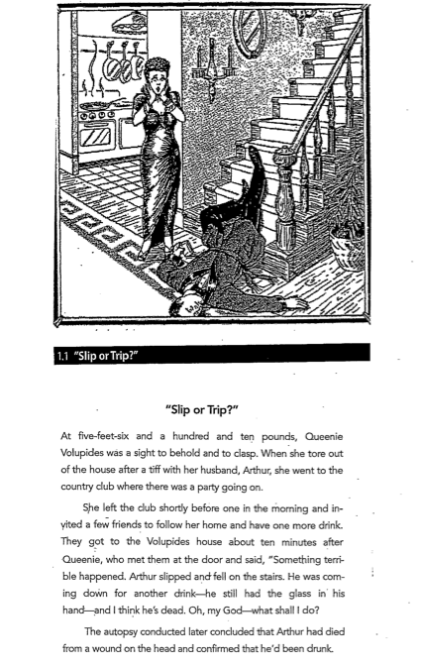

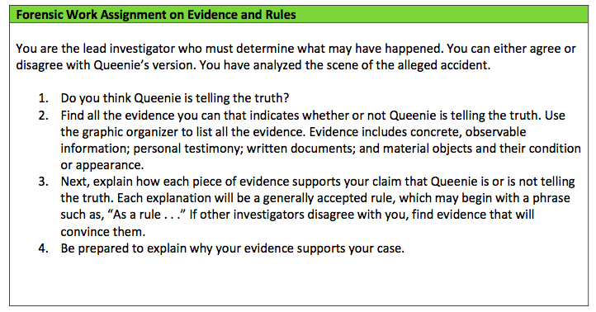

To summarize:
For this activity, you will practice the Toulmin argument by composing a forensic argument.
- Analyze the photo, taking note of all that you see (page 1)
- Afterward, you will read the investigator's evidence and rules (page 2)
- Use the graphic organizer to qualify your response (page 3)
No cover page and no reference page. Just send me the page 3 with answer in there

Task 6: The Case of Slip or Trip

Evidence (Data/Grounds) | General Rule (Warrants) | Conclusion (Claim)

Qualifiers:

Sentence Frame:
Because (support/ data(s)), therefore (claim(s)), since (warrant(s)) because/ on account of (backing(s)).

